Response to Reviewers

Manuscript (ID: STBU-2026-159): Multi-objective Optimization Design of Marine Structures Based on An Enhanced Starfish Algorithm

Authors: Thanh Do-Quang, T. Vu-Huu, and Thanh Cuong-Le
Dear Editor and Reviewers,
We sincerely thank the Editor and both Reviewers for their careful assessment of our manuscript and for the constructive comments. We have revised the manuscript point by point. Newly added or substantially revised passages are highlighted in yellow in the revised manuscript, as requested.
The main revisions include restructuring and shortening dense sections, enriching the Introduction, revising the benchmark tables and figures, recalculating the benchmark data, adding statistical validation, adding computational-cost and sensitivity analyses, expanding the B-MOSFOA and E-MOSFOA algorithm descriptions, clarifying SAP2000/geotechnical/cost/load assumptions, adding a Limitations section, and improving English language and terminology consistency.
Below, each comment is reproduced, followed by our response and the corresponding changes made in the revised manuscript.

Response to Reviewer 1:
- The study is very dense with information and formulas. Furthermore, it includes many subheadings, which limits its clarity and readability. Therefore, simplifications should be made, the formulas should be grouped together, and the subheadings should be reconfigured.
Thank you for this helpful suggestion. The manuscript has been substantially reorganized throughout Sections 2-5 and Appendix A to improve clarity and readability. The number of headings in the main text has been reduced from 30 to 16, and all third-level numbered subsections have been removed. Closely related explanations, equations, experimental evidence, and engineering discussions have been consolidated and arranged in a more logical sequence, while the equations are presented in coherent groups and numbered sequentially from (1) to (23). New material added in response to the reviewers has been placed within the relevant methodological or analytical context, whereas the detailed workflow, benchmark statistics, sensitivity evidence, and other extensive supporting results have been transferred to Appendix A. The revised structure therefore provides a clearer progression from methodology to numerical validation, engineering application, and conclusions without interrupting the discussion with numerous short subsections.
- The Introduction should be enriched. The number of studies on this topic should be increased, and the purpose, scope, and methodology of the study should be emphasized in the paragraph at the end of the chapter.
Thank you for this helpful suggestion. Section 1 has been substantially revised to provide a broader research background and clearer positioning of the study. The revision adds discussion of marine-jetty design trade-offs, Pareto-based multi-objective optimization, recent comparator algorithms, the limitations of applying the original single-objective SFOA, the rationale for developing B-MOSFOA and E-MOSFOA, and the use of benchmark suites, performance indicators, statistical testing, and the MATLAB-SAP2000 case study. The final paragraph now states the purpose, scope, methodology, and organization of the manuscript. Because the Introduction was comprehensively rewritten, only the Section 1 heading is highlighted in yellow to identify the revised content block; the substantive additions are described in this response.
- The study should include subheadings under the "Materials and Methods" section, and a flowchart showing all the steps of the study should be attached.
Thank you for this helpful suggestion. The methodology is now organized into Sections 2.1-2.3 with clear subheadings. Algorithm 1 and Fig. 1 in Section 2.3 describe the computational workflow shared by B-MOSFOA and E-MOSFOA. The complete study workflow, from formulation and algorithm development through benchmark validation, statistical assessment, SAP2000-based engineering analysis, constraint verification, and design interpretation, is presented at the beginning of Appendix A as the newly added Fig. A1, entitled “Overall research workflow for algorithm development, benchmark evaluation, and marine-jetty design optimization.” The final paragraph of Section 1 cites Fig. A1 and explains the organization of the study.
The Fig. A1 citation in the final paragraph of Section 1 is highlighted in yellow, together with the relevant methodology headings and Fig. A1 caption.
- Table 3, 4, and 5 are unclear. The numbers in the table are quite small. It would be more meaningful to write these numbers as 0, 00... or similar.
Thank you for this helpful suggestion. We revised the benchmark tables to improve readability. The detailed IMOP, UF, and RM-MEDA results were moved to Appendix Tables A2-A4. Indicator values are shown to five decimal places, while values below 10-4 are reported in compact scientific notation so that their magnitude remains visible. The former roman-numeral identifiers were replaced by fixed column codes A1-A5. Each table note maps these codes to MOMSA, NS-MFO, MOGNDO, B-MOSFOA, and E-MOSFOA and identifies the Best, Mean, Std, Rank, and Wilcoxon rows; Section 3.1 defines the Wilcoxon-Holm symbols. In Section 3.2, Table 3 reports computational settings and runtime statistics, whereas Table 4 summarizes average ranks, rank-1 and top-2 counts, W/D/L outcomes, valid-test counts, and significant Holm-adjusted comparisons. Table 5 in Section 3.3 provides the reduced parameter-sensitivity summary.
The captions of Appendix Tables A2-A4 are highlighted in yellow to mark the revised detailed benchmark tables.
- What are the limitations of the study? This should be written under the heading "Limitations".
Thank you for this important comment. To state the study limitations explicitly without fragmenting the concise final section into additional numbered subsections, Section 5 retains the integrated title “Conclusions, Limitations, and Future Work” and presents the limitations under a distinct bold run-in heading, “Limitations.” Two limitations are identified: the conventional code-based pile calculations and equivalent guided-and-roller support representation do not fully capture nonlinear soil-pile interaction or soil-mediated pile-group effects; and evaluating every candidate through SAP2000 entails substantial computational cost. A following run-in heading, “Future work,” states the corresponding research directions, including higher-fidelity soil-structure interaction models and surrogate or adaptive-sampling strategies for reducing full SAP2000 evaluations.
The complete Limitations paragraphs in Section 5 are highlighted in yellow.
- Finite element analysis was performed using Sap2000 software, but the Abstract should have included the numerically best performing system or presented the numerical results.
Thank you for this helpful suggestion. The Abstract now identifies the coupled MATLAB-SAP2000 framework and gives a quantitative engineering result rather than only describing the optimization procedure. The mooring dolphin is identified as the subsystem with the strongest simultaneous improvement relative to its current design. Both B-MOSFOA and E-MOSFOA recover the same minimum-cost design A/I: construction cost decreases from USD 13,121.12 to USD 2,422.23 and maximum displacement decreases from 0.04268 m to 0.02459 m, corresponding to reductions of 81.5% and 42.4%, respectively. The Abstract reports these percentage reductions remain concise. The underlying objective values and design variables are provided in Section 4.5 and Table 11. The Abstract also places this result in its feasibility context by stating that all six final archives satisfy the implemented strength, geotechnical, and geometric constraints; the archive-wide verification in Table 13 gives a maximum pile-utilization ratio of 0.9971.
The quantitative engineering-result sentence in the Abstract is highlighted in yellow.
- Why were marine structures chosen? This should be emphasized further in the text of the study.
Thank you for this important comment. The reason for selecting marine structures is now stated explicitly at the beginning of Section 1 and substantiated in Sections 4.1-4.4. A pile-supported liquid-bulk jetty provides a practical constrained multi-objective design problem because construction cost, structural stiffness, and pile-foundation performance cannot be improved independently. Reducing pile size or length can lower material cost but may increase displacement, pile-force demand, or the risk of placing the pile tip in an unsuitable soil layer; increasing stiffness generally has the opposite cost effect. The selected project also contains three functionally different but connected subsystems: the berthing dolphins resist berthing actions, the mooring dolphins transfer mooring actions, and the main jetty platform carries operational dead and live loads. The proposed framework is therefore examined under different loading conditions and design variables within one real project. Each candidate is analysed in SAP2000 and must satisfy the applicable structural, geotechnical, and geometric requirements, including uplift where relevant. These characteristics make the jetty an appropriate case for demonstrating meaningful Pareto trade-offs rather than reducing the design to a single prescribed optimum.
The rationale sentence in Section 1 and the case-study context sentence in Section 4 are highlighted in yellow.
- The study contains too many abbreviations. It takes time to understand what each one means. The number of abbreviations should be reduced.
Thank you for this important comment. A manuscript-wide abbreviation audit was undertaken. Full terms are preferred in the running text, and abbreviations are limited to maintain readability; the former roman-numeral algorithm labels were also removed. B-MOSFOA and E-MOSFOA are used consistently in the running text, while the compact appendix codes A1-A5 are mapped to the five full algorithm labels in every relevant table note. The Abstract now writes berthing dolphin, mooring dolphin, and main jetty platform in full. Their shortened forms BD, MD, and MJP are introduced only at the beginning of Section 4.1, where repeated use is needed in the engineering tables and figures. Section 3.1 now states the full names of the epsilon indicator ($ϵ$), inverted generational distance ($IGD$), spread ($Δ$), and maximum spread ($MS$) before using their compact labels. Table 6 retains the compact labels DL, BL, ML, and LL, while their meanings are defined in the text immediately below the table. By contrast, abbreviations are preferred in tables and figures to keep labels compact and readable. These retained abbreviations mainly comprise established algorithm names, benchmark-suite identifiers, metric labels, and engineering labels; each is defined at first use or in the corresponding table or figure note. All mathematical symbols were also reviewed and explained with their first occurrence, equation, or table. This approach reduces the reading burden without repeatedly expanding long technical names in dense result tables.
The first-use definitions of the main structural and load abbreviations in Section 4.1 are highlighted in yellow; repeated table and figure labels remain abbreviated.
- A language check should be performed after all revisions.
Thank you for this helpful suggestion. After the technical revisions were consolidated, the complete manuscript underwent a language and consistency review. The review covered grammar, sentence structure, article and preposition use, subject-verb agreement, punctuation, hyphenation, terminology, symbols, units, figure captions, and table notes. Long or repetitive sentences were shortened where this improved clarity, and informal or ambiguous wording was replaced with established technical language. The specific expressions identified by the reviewers were corrected; for example, “flexing” was replaced by “flexure” or “bending” according to context, and “well suited” was standardized as “well-suited” when used adjectivally. Algorithm names and engineering terminology were also checked for consistent use across the Abstract, main text, tables, figures, and Conclusions. A final proofread of the consolidated revised manuscript has therefore been completed.
Language corrections are distributed throughout the manuscript and are therefore not highlighted individually; the consolidated revised text has been proofread as a whole.
Thank you for being so supportive!

Response to Reviewer 2:
Overall recommendation: Major Revision Required - The paper presents valuable contributions but has significant technical and presentation issues that must be addressed.
- Unrealistic Benchmark Results. In Table 2 (IMOP1), B-MOSFOA achieves IGD=0.00, epsilon=0.00, Delta=0.00, MS=0.00 - perfect convergence to the Pareto front. This is highly improbable for a stochastic algorithm and suggests either an error in implementation, incorrect reference PF, or overfitting. Please verify these results and provide explanation.
Thank you for pointing this out. We found that the original code did not preallocate the indicator-history arrays. When an indicator was not evaluated at an iteration because the archive contained fewer than two solutions, MATLAB filled the corresponding array position with its default value of zero. The table script then read the final column and incorrectly treated this zero as a calculated result. We corrected the code by initializing all history arrays with NaN and extracting the last valid value from each run. The analytical reference front was also verified and is used only for indicator calculation, not to guide the search. IMOP1 was rerun for 30 independent runs; the revised B-MOSFOA mean values are 0.01233, 0.45221, 1.12925, and 0.84844 for $IGD$, $ϵ$, $Δ$, and $MS$, respectively. These are not perfect-convergence results. Moreover, MS is maximized, so MS = 0 would indicate no spread rather than an ideal result. Small values are now reported with five decimals or scientific notation. The corrected results and discussion appear in Section 3.2, Appendix Table A2, and Figs. 2-3.
Appendix Table A2, which contains the corrected IMOP results, is highlighted in yellow.
- Missing Statistical Validation. Results from 30 runs are reported without statistical significance testing. Please add Wilcoxon signed-rank tests or similar to demonstrate significant differences between algorithms.
We agree that mean values and ranks alone are insufficient. Because the results of different algorithms are independent samples, two-sided Wilcoxon rank-sum tests were used instead of the paired signed-rank test. For each problem and indicator, the 30 E-MOSFOA results were compared with the 30 results from each of the other four algorithms. Holm adjustment was then applied to these four p-values at α = 0.05. Invalid values were removed, and comparisons with insufficient valid data were excluded rather than treated as zeros. Section 3.1 defines this procedure and the preferred direction of each indicator. Appendix Tables A2-A4 use +, -, and = when E-MOSFOA is significantly better, significantly worse, or not significantly different; Ref. marks its reference column. Table 4 summarizes these outcomes as W/D/L and also reports the number of valid tests and the number with padj < 0.05. Table 4 gives the aggregate reading of the detailed results in Appendix Tables A2-A4. The statistical results therefore support the performance discussion without implying universal superiority.
The statistical-testing paragraph in Section 3.1 is highlighted in yellow; the detailed comparison symbols remain available in Appendix Tables A2-A4.
- No Computational Cost Analysis. CPU time and function evaluations are omitted. For practical engineering applications, this is essential. Please include run time comparisons.
Thank you for pointing this out. Computational effort is now reported for both the benchmark experiments and the engineering applications. Section 3.2 specifies the workstation and parallel configuration, while Table 3 reports the mean computation time per independent run, mean function evaluations per run, and final archive size for every benchmark algorithm. Reporting computation time per run avoids confusing it with the completion time of the 30-run parallel batch. For the engineering cases, Section 4.5 states that each algorithm-case pair uses 30,100 objective evaluations and couples the admissible candidate evaluations with SAP2000. Table 13 reports the computation time of each complete optimization: 12.92 and 12.87 h for BD, 6.91 and 6.73 h for MD, and 4.32 and 5.09 h for MJP under B-MOSFOA and E-MOSFOA, respectively. All six engineering optimizations were performed on the same workstation with 25 parallel SAP2000 instances. Because only one complete engineering run is available for each algorithm-case pair, these times are interpreted descriptively and are not used to claim statistically significant differences in computation time.
The captions of Tables 3 and 13, the mean-computation-time column in Table 3, the computation-time column in Table 13, and the engineering function-evaluation statement in Section 4.5 are highlighted in yellow
- Parameter Sensitivity. Algorithm parameters (GP0, archive size, grid size) are used without justification. Please provide sensitivity analysis or explanation for parameter selection.
Thank you for this helpful suggestion. We added a parameter-setting and sensitivity analysis. A one-factor-at-a-time experiment was conducted for the initial exploration probability GP0, archive size Nr, and grid size ngrid using six representative benchmark problems (IMOP1, IMOP4, UF3, UF8, RM-MEDA-F1, and RM-MEDA-F4), 30 independent runs per configuration, and the same evaluation budget as the main benchmark. The common baseline used for both B-MOSFOA and E-MOSFOA in the main benchmark was $GP_{0}$ = 0.5, $N_{r}$ = 200, and $n_{grid}$ = 10. Table 5 now reports mean rank, best-count, Wilcoxon-Holm comparison counts against this baseline, and mean computation time per run. The tested values $GP_{0}$ = 0.3 and $GP_{0}$ = 0.7 are sensitivity scenarios rather than settings used to generate the main benchmark results. Their outcomes indicate moderate and variant-dependent parameter responses, while archive size mainly affects computation time. The Wilcoxon-Holm subtotals show that 121/144 B-MOSFOA comparisons and 111/144 E-MOSFOA comparisons are not significantly different from the baseline, supporting robustness within the investigated range.
The sensitivity-analysis paragraphs in Section 3.3 and the captions of Table 5 and Appendix Table A1 are highlighted in yellow.
- Engineering Case Study - Constraint Handling. Penalty coefficients (alpha_i) in equations (24-25) are not specified. Please provide values and verify all optimized solutions satisfy constraints.
We agree that this information is important. Section 4.4 has been revised as “Constraint Handling and Feasibility Verification.” The penalty formulation cited in the original manuscript is now presented as Eqs. (22) and (23). The implementation uses one common coefficient, $α={10}^{9}$, rather than unspecified individual αi values. Positive exceedances of the pile-moment, axial-compression, and applicable uplift limits are combined, multiplied by α, and added to both objectives. The uplift term applies to BD and MD and is zero for MJP. Four hard conditions are checked before SAP2000 analysis: pile length relative to calculated flexural length, pile-tip liquidity index, thickness of the bearing soil-layer, and beam-pile geometric compatibility for MJP. Failure of any hard condition bypasses SAP2000 and assigns ${10}^{9}$ directly to both objectives. Thus, the same value is used consistently for resistance violations and hard pre-analysis failures.
In addition, feasibility is verified for every member of each final archive, rather than only for the representative designs. A solution is feasible when $P(X)$ = 0, all hard pre-analysis conditions are satisfied, and every applicable demand-to-resistance ratio does not exceed 1.0. Table 13 reports feasible/archive counts of 7/7 and 9/9 for BD, 9/9 and 10/10 for MD, and 80/80 and 100/100 for MJP under B-MOSFOA and E-MOSFOA, respectively. The largest utilization ratio among all six archives is 0.9971. These results confirm that every retained solution satisfies the implemented constraints.
The revised constraint-handling paragraphs, Eqs. (22)-(23), and the final-archive verification statement linked to Table 13 are highlighted in yellow.
- Inconsistent Performance Claims. In Section 4.1, state "E-MOSFOA achieves best IGD in 5 out of 8 problems" but Table 2 shows 6 out of 8 (IMOP2,3,4,7,8 and IMOP1 excluding unrealistic B-MOSFOA result). Correct this.
Thank you for pointing this out. The original 5-of-8 $IGD$ statement was removed after the benchmark results were recalculated from the 30 independent runs, and it is not retained as a performance claim in the revised manuscript. Appendix Table A2 now reports Best, Mean, Std, Rank, and Wilcoxon-Holm outcomes for each of the eight IMOP problems and four indicators. Section 3.2 and Table 4 then summarize all 32 problem-indicator combinations rather than relying on the count for IGD alone. Under this broader assessment, B-MOSFOA obtains the best IMOP average rank of 2.28, with 8 rank-1 and 21 top-2 cases; E-MOSFOA has an average rank of 2.44, with 13 rank-1 and 18 top-2 cases. The revised discussion therefore distinguishes the stronger aggregate rank of B-MOSFOA from the larger number of individual first-place outcomes of E-MOSFOA. This interpretation is consistent with Tables 4 and A2 and avoids overstating either variant on the basis of one indicator.
The corrected aggregate benchmark discussion in Section 3.2 and the caption of Table 4 are highlighted in yellow.
- Language Quality. Significant grammatical errors throughout. Example: "flexing" should be "flexure" or "bending"; "well suited" -> "well-suited". Requires thorough editing by native English speaker.
We agree that this information is important. After the technical revisions were consolidated, the complete manuscript underwent English-language editing and final proofreading. The review covered grammar, article and preposition use, subject-verb agreement, punctuation, hyphenation, sentence structure, and technical word choice. Long or repetitive sentences were shortened where necessary, report-like wording was replaced by direct academic discussion, and the main analysis was standardized toward the present tense and an impersonal style. The examples identified by the Reviewer were corrected explicitly: “flexing” was replaced by “flexure” or “bending” according to context, and adjectival “well suited” was changed to “well-suited”. A final consistency check covered the Abstract, main text, equation explanations, table notes, figure captions, and Conclusions. The revised manuscript no longer contains the expression “flexing” or the unhyphenated adjectival form “well suited”.
Language corrections are distributed throughout the manuscript and are therefore not highlighted individually; the revised text has been proofread as a complete document.
- Terminology Inconsistency. Terms used interchangeably: "B-MOSFOA"/"Base MOSFOA"/"IV"; "E-MOSFOA"/"Enhanced MOSFOA"/"V". Use consistent labels throughout.
Thank you for pointing this out. The algorithm terminology has been standardized throughout the revised manuscript. The descriptive forms “base multi-objective SFOA” and “enhanced multi-objective SFOA” appear only when B-MOSFOA and E-MOSFOA are first defined in the Abstract. Thereafter, B-MOSFOA and E-MOSFOA are used consistently in the main text, algorithms, tables, figure legends, captions, and Conclusions. The former alternatives “Base MOSFOA”, “Enhanced MOSFOA”, IV, and V have been removed. The main-text tables display the fixed algorithm names directly. Only the very wide detailed Tables A2-A4 use the compact column codes A1-A5 to preserve readability; every table note explicitly maps A1=MOMSA, A2=NS-MFO, A3=MOGNDO, A4=B-MOSFOA, and A5=E-MOSFOA. These codes are therefore table-column identifiers rather than alternative algorithm names.
Terminology has been standardized throughout the manuscript, tables, figures, and captions; these distributed label corrections are not highlighted individually. The A1-A5 mappings are retained in the notes of Appendix Tables A2-A4.
- Incomplete Algorithm Description. DE mutation integration (equations 9-10) lacks motivation and explanation; crossover operation (equation 11) type not specified; adaptive grid implementation details missing; boundary handling mechanism not described. Please provide complete algorithmic details.
We agree that this information is important. Sections 2.2 and 2.3 now provide the missing implementation details. Eqs. (9)-(10) define leader-guided Differential Evolution mutation using three sampled members, $λ=0.3$, and a mutation scale decreasing from 0.5 to zero; Eq. (11) specifies binomial crossover with $CR=0.5$. Archive updating removes dominated solutions, limits capacity by crowding-distance truncation, and divides each objective range into ngrid intervals. The probability $P_{i} = c/N_{i}$ favors leaders from sparse cells. B-MOSFOA restores invalid coordinates before projection, whereas E-MOSFOA projects all trial and refined vectors onto the bounds.
The revised archive-grid, boundary-handling, Differential Evolution/crossover, and refinement descriptions in Sections 2.2 and 2.3, together with Eqs. (7) and (9)-(13), are highlighted in yellow.
- Missing Cost Data Sources. Material prices (P_p, P_cr, P_st) in equations (18-19) and Tables 9-11 are unsourced. Provide clear references with dates.
Thank you for pointing this out. Section 4.2 now identifies the unit-cost basis and its dates. The case study uses an indicative 2025 dataset rather than a tender estimate. The official Hai Phong construction-material announcements applicable from January 2025 and issued for May 2025 are the primary references for prestressed spun concrete piles, M400 concrete, and reinforcement [42,43]. Public supplier lists are used only as supplementary evidence for pile diameters and classes not separated in the official announcements. Where no published value is available, the price is estimated from neighboring diameters, section dimensions, pile class, and engineering experience. Table R1 reproduces all 44 rows and eight columns actually stored in X1_X2.mat. The first six columns describe the pile properties defined by TCVN 7888:2014 [3], column 7 records the adopted local unit price, and column 8 is the corresponding Pp value supplied directly to the BD, MD, and MJP calculations. The calculation uses Pcr = 46.25 USD/m3, Pst = 0.57 USD/kg, and the fixed conversion 1 USD = 24,500 VND. This dataset was fixed before optimization and applied unchanged to every candidate and both algorithms. It therefore provides a consistent basis for comparing design alternatives, while current project quotations remain necessary for tendering or construction.
Primary official pile-price source: Hai Phong construction-material price announcement applicable from January 2025, section “Prestressed spun concrete piles,” published through the construction-economics information system: official Hai Phong price announcement. The listed prices exclude VAT and apply at construction sites within the stated 20-30 km delivery range in Hai Phong.
Public price evidence: (i) Mai Son Phat, prestressed spun concrete pile price list D300-D600 (2025); (ii) An Gia Construction, prestressed spun-pile price list D300-D600 (published 9 May 2023); (iii) Dai Duong, prestressed spun-pile price list and D300-D1200 manufacturing range (published 11 September 2025); (iv) Ep Coc Ly Tam, detailed D500-D600 material prices and installation rates; and (v) Ep Coc Ly Tam, D300-D600 material, transport, and installation price components.
Official 2025 comparison sources: Hai Phong Department of Construction, price announcement applicable from January 2025 and construction-material prices for May 2025. The announced prices exclude VAT; the stated transport and supplier conditions differ by product.
The revised definitions of the price variables and the 2025 price-basis paragraph after Eq. (15) are highlighted in yellow. Table R1 below provides the supporting pile-price matrix.
          - Pile-property and unit-price of pile used in the BD, MD, and MJP calculations.
Diameter  D (mm) | Wall thickness  t (mm) | Load class | Cracking bending moment (kN·m) | Effective prestress (MPa) | Shear capacity (kN) | Price  (VND/m) | P_{p}  (USD/m)
300 | 60 | A | 24.5 | 4 | 99.1 | 198,922 | 8.1193
300 | 60 | AB | 30.0 | 6 | 111.0 | 240,198 | 9.8040
300 | 60 | B | 34.3 | 8 | 125.6 | 258,598 | 10.5550
300 | 60 | C | 39.2 | 10 | 136.4 | 284,458 | 11.6105
350 | 60 | A | 34.3 | 4 | 118.7 | 245,954 | 10.0389
350 | 60 | B | 49.0 | 8 | 150.1 | 319,740 | 13.0506
350 | 60 | C | 58.9 | 10 | 162.8 | 351,714 | 14.3557
400 | 65 | A | 54.0 | 4 | 148.1 | 322,597 | 13.1672
400 | 65 | AB | 64.0 | 6 | 176.0 | 370,986.5 | 15.1423
400 | 65 | B | 73.6 | 8 | 187.4 | 419,376 | 17.1174
400 | 65 | C | 88.3 | 10 | 204.0 | 461,314 | 18.8291
450 | 70 | A | 73.6 | 4 | 180.5 | 412,115 | 16.8210
450 | 70 | B | 107.9 | 8 | 227.6 | 535,749 | 21.8673
450 | 70 | C | 122.6 | 10 | 248.2 | 589,324 | 24.0540
500 | 80 | A | 103.0 | 4 | 228.6 | 476,993 | 19.4691
500 | 80 | AB | 125.0 | 6 | 271.0 | 572,391.5 | 23.3629
500 | 80 | B | 147.2 | 8 | 288.4 | 667,790 | 27.2567
500 | 80 | C | 166.8 | 10 | 313.9 | 734,569 | 29.9824
600 | 90 | A | 166.8 | 4 | 311.0 | 631,629 | 25.7808
600 | 90 | AB | 206.0 | 6 | 362.0 | 773,745.5 | 31.5814
600 | 90 | B | 245.2 | 8 | 392.4 | 915,862 | 37.3821
600 | 90 | C | 284.5 | 10 | 427.7 | 1,053,241 | 42.9894
700 | 100 | A | 264.9 | 4 | 406.1 | 787,846 | 32.1570
700 | 100 | AB | 319.0 | 6 | 437.0 | 964,264.5 | 39.3577
700 | 100 | B | 372.8 | 8 | 512.1 | 1,140,683 | 46.5585
700 | 100 | C | 441.4 | 10 | 557.2 | 1,292,041 | 52.7364
800 | 110 | A | 392.4 | 4 | 512.1 | 990,394 | 40.4242
800 | 110 | AB | 471.0 | 6 | 595.0 | 1,228,116 | 50.1272
800 | 110 | B | 539.6 | 8 | 646.5 | 1,465,838 | 59.8301
800 | 110 | C | 637.6 | 10 | 704.4 | 1,670,834 | 68.1973
900 | 120 | A | 539.6 | 4 | 631.0 | 1,245,014 | 50.8169
900 | 120 | B | 735.8 | 8 | 797.0 | 1,883,679 | 76.8849
900 | 120 | C | 833.8 | 10 | 867.0 | 2,160,680 | 88.1910
1000 | 130 | A | 735.8 | 4 | 762.2 | 1,565,096 | 63.8815
1000 | 130 | AB | 883.0 | 6 | 774.0 | 1,992,862 | 81.3413
1000 | 130 | B | 1,030.0 | 8 | 961.4 | 2,420,628 | 98.8011
1000 | 130 | C | 1,177.0 | 10 | 1,047.0 | 2,794,136 | 114.0464
1100 | 140 | A | 932.0 | 4 | 905.0 | 1,967,467 | 80.3048
1100 | 140 | B | 1,324.0 | 8 | 1,142.0 | 3,110,635 | 126.9647
1100 | 140 | C | 1,521.0 | 10 | 1,244.0 | 3,613,306 | 147.4819
1200 | 150 | A | 1,177.0 | 4 | 1,059.0 | 2,473,284 | 100.9504
1200 | 150 | AB | 1,412.0 | 6 | 1,292.0 | 3,235,307.5 | 132.0534
1200 | 150 | B | 1,668.0 | 8 | 1,337.0 | 3,997,331 | 163.1564
1200 | 150 | C | 1,962.0 | 10 | 1,457.0 | 4,672,634 | 190.7198
- Reference Incompleteness. Reference [35] is cited but not in reference list (TCVN 7888:2014 is [31]); some references lack complete information; format not consistent with ICE style.
Thank you for pointing this out. The in-text citations and reference list have been rebuilt as one continuous numbered system and checked entry by entry. The mismatch involving the former Reference [35] has therefore been removed; TCVN 7888:2014 and TCVN 10304:2014 now appear consistently as References [3] and [4]. Missing bibliographic information has been completed, including the responsible author or institution, title, publication source, year, volume, issue, page range, publisher, and available DOI or URL, as applicable. The entries have also been standardized to the numbered ICE reference style. The revised manuscript contains 46 references: every entry is cited in the text, every citation has a corresponding reference-list entry, and no listed source is unused. These corrections apply throughout the manuscript and the complete revised reference list.
- Figure Quality. Figures 1-6: Low resolution, poor color differentiation (red/green). Figure 7: Uses copyrighted Google Maps material - need permission. Figures 9-10: Axes need units.
Thank you for pointing this out. The benchmark plots in the current Figs. 2-7, corresponding to the benchmark figures identified in the comment, were regenerated from the revised data as individual 600 dpi PNG files. Their layouts and text sizes were revised, and the algorithm series are distinguished by both marker shape and color rather than by red-green contrast alone. The engineering plots are likewise supplied as high-resolution PNG and vector SVG files. Their axes now state f₁ - Cost (USD) and f₂ - Displacement (m); the convergence panel uses Iteration and Hypervolume (HV).
The satellite image in the original Fig. 7, now Fig. 8(a), was replaced by a clean 1800 × 897 px, 300 dpi Google Earth capture. Browser controls and transient interface messages are excluded, whereas the native Google and third-party data attribution remains visible and unobscured. The added BD1, BD2, MD1, MD2, and MJP labels do not cover the attribution. The revised caption identifies Google Earth as the source and states the imagery date (13 March 2026), access date (11 July 2026), and retention of the native attribution. Google’s Geo Guidelines state that Google Earth content may be used for research without requesting separate permission and list journals among the permitted print uses, provided the applicable conditions and attribution requirements are followed.
The captions of Figs. 2-10 are highlighted in yellow to identify the regenerated benchmark plots, the revised Google Earth panel, and the engineering figures with updated axis units. The individual high-resolution files are supplied separately.
- Equation Numbering. Many equations appear as "()" instead of numbered (equations 1, 18-19). Please number all equations sequentially.
Thank you for pointing this out. All displayed equations have been reviewed and numbered in one continuous sequence from (1) to (23); the empty labels that appeared as “()” in the original manuscript have been removed. Equations (1)-(13) now present the multi-objective formulation and the B-MOSFOA and E-MOSFOA operators in Section 2, while Eqs. (14)-(23) define the engineering objectives, pile-resistance checks, and penalty formulation in Section 4. The associated references in the explanatory text and Algorithm 1 have been updated to the same numbering. A final check confirms that the sequence contains no missing or duplicate equation numbers.
- Section Organization. Section 3.1 has duplicate subsections labeled "a, b, c" repeatedly. Restructure with consistent numbering.
Thank you for this helpful suggestion. The repeated subsections labelled “a, b, c” have been removed, together with the unnecessarily deep heading level. Section 3 now follows one consistent numerical hierarchy: Section 3.1 introduces the benchmark suites, performance metrics, statistical procedure, and experimental protocol; Section 3.2 presents the benchmark results and computational cost; and Section 3.3 reports the parameter-sensitivity analysis. The IMOP, UF, and RMMEDA evidence is discussed within the unified Section 3.2 rather than under repeated lettered headings, while the extensive problem-level tables are placed in Appendix A. This organization gives direct progression from experimental definition to comparative results and then sensitivity assessment.
- Abbreviations. BD, MD, MJP used in abstract without definition. Define upon first use.
Thank you for pointing this out. BD, MD, and MJP have been removed from the Abstract, which now writes berthing dolphin, mooring dolphin, and main jetty platform in full. The abbreviations are introduced only at the beginning of Section 4.1 as berthing dolphins (BD), mooring dolphins (MD), and main jetty platform (MJP), before their repeated use in the engineering tables, figures, and results. The abbreviation review also removed MOO, PS, and NFL from the running text, while the metric names are written in full before EPS, IGD, DELTA, and MS are used in Section 3.1. Hypervolume is written as normalized hypervolume (HV) at its first use in Section 4.5, and FEA is defined in the Table 13 note. Load symbols such as DL, BL, ML, and LL are retained mainly in Tables 6 and 8 and are explained in their surrounding text or notes. Each retained abbreviation is therefore defined at its first relevant occurrence.
The newly expanded abbreviation definitions are highlighted in yellow at the relevant first-use locations in Sections 1, 3.1, and 4.5, and in the Table 13 note.
- Current Design Context. The "current design" used for comparison (Tables 9-11) lacks description of original design methodology and standards used. Provide context.
In the revised manuscript, “current design” refers to baselines established from non-public project records made available to the authors for research verification. The 2020 as-built drawing dossier records the completed BD and MD configurations, while the 2023 periodic-inspection calculation dossier describes all three structures-BD, MD, and MJP-including their geometry, soil conditions, actions, and structural arrangements [39,40].
These records are used to establish calculation models of the existing structures as comparison baselines. The same two objectives are then evaluated: $f_{1}$ is construction cost and $f_{2}$ is maximum structural displacement. Table R2 below in this response letter summarizes the baseline configurations. The design basis follows TCVN 7888:2014, TCVN 10304:2014, PIANC, OCDI, 22 TCN 222-95, and CSA A23.3-14; Sections 4.1-4.3 and Tables 6 and 8 of the revised manuscript provide the corresponding details.
          - Traceability of the current design baselines used in the engineering comparison.
Subsystem | Project evidence | Baseline calculation configuration | Role in comparison
BD | 2020 as-built repair dossier; drawings TKBVTC/SC-01/5 and TKBVTC/SC-03/5 | 19 D600 piles: 9 vertical and 10 raker; rake 1:6; nominal length 39 m | Project baseline for calculating f₁ and f₂
MD | 2023 periodic-inspection calculation dossier | 9 D600 piles: 1 vertical and 8 raker; rake 1:6; nominal length 39 m | Project baseline for calculating f₁ and f₂
MJP | 2023 periodic-inspection calculation dossier | Vertical D500 piles; nominal length 38 m; project beam and deck configuration | Project baseline for calculating f₁ and f₂
The paragraph in Section 4.1 describing the project records, baseline configurations, and common reanalysis is highlighted in yellow. The standards paragraph at the beginning of Section 4.3 is also highlighted. Tables 10-12 retain the corresponding current-design rows used for the numerical comparison.
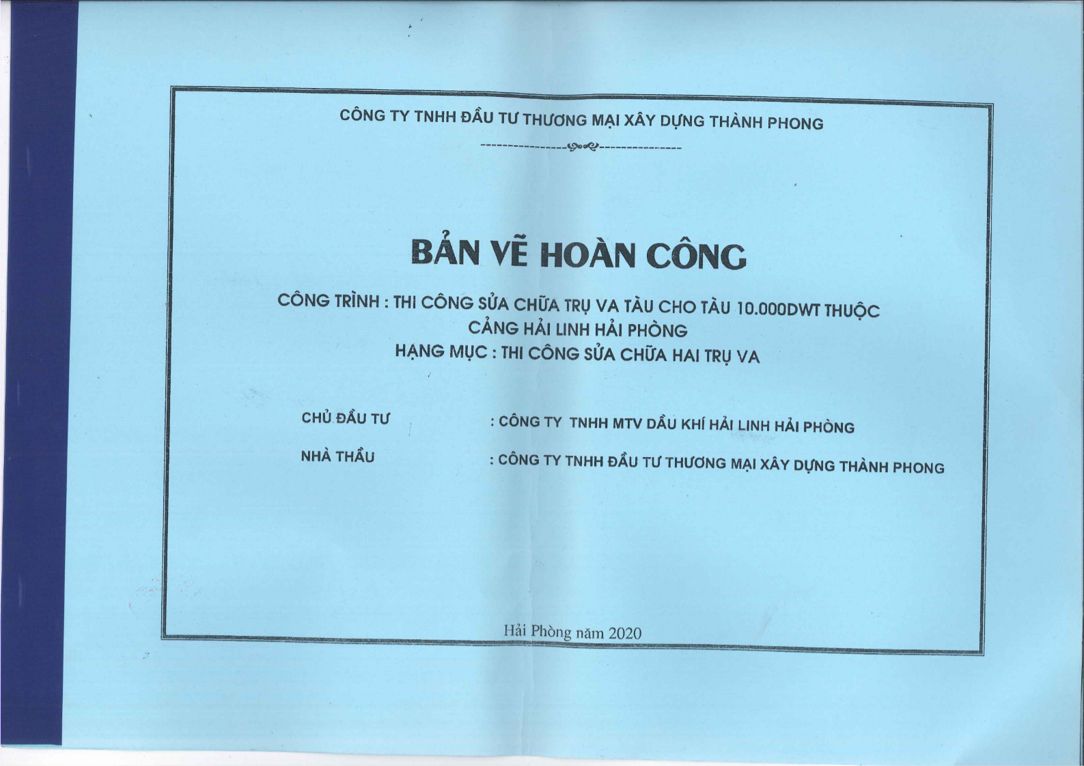
        - Technical-drawing dossier for Hai Linh Petroleum Port, Hai Phong, Vietnam (2020).
The supporting source documents are non-public project records and are not presented as public references. Selected, non-sensitive excerpts are shown in Fig. R1; the original records are in Vietnamese. The complete dossier can be supplied confidentially to the editor or reviewers, subject to the document owner’s permission.
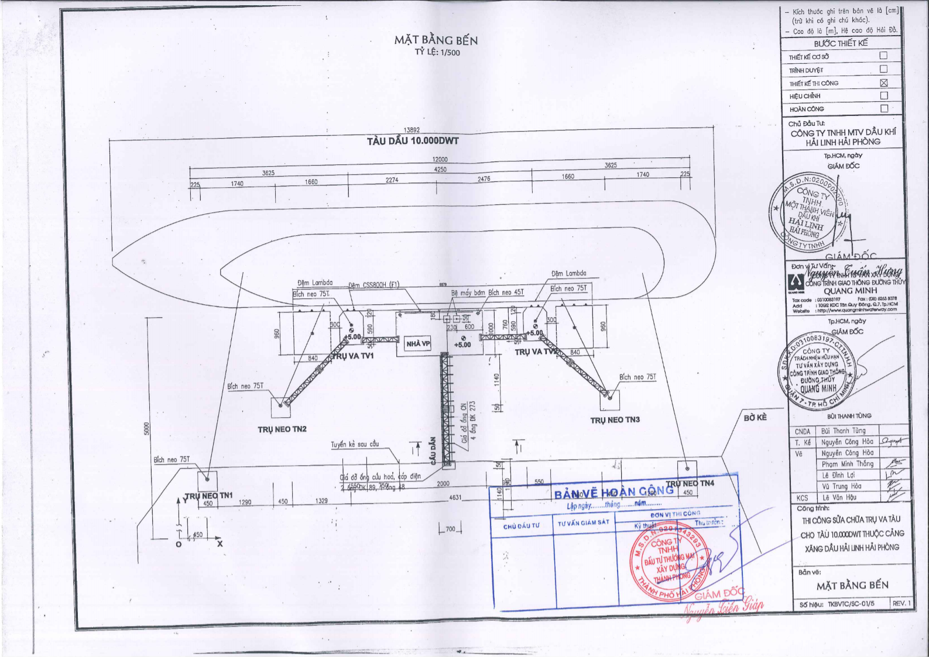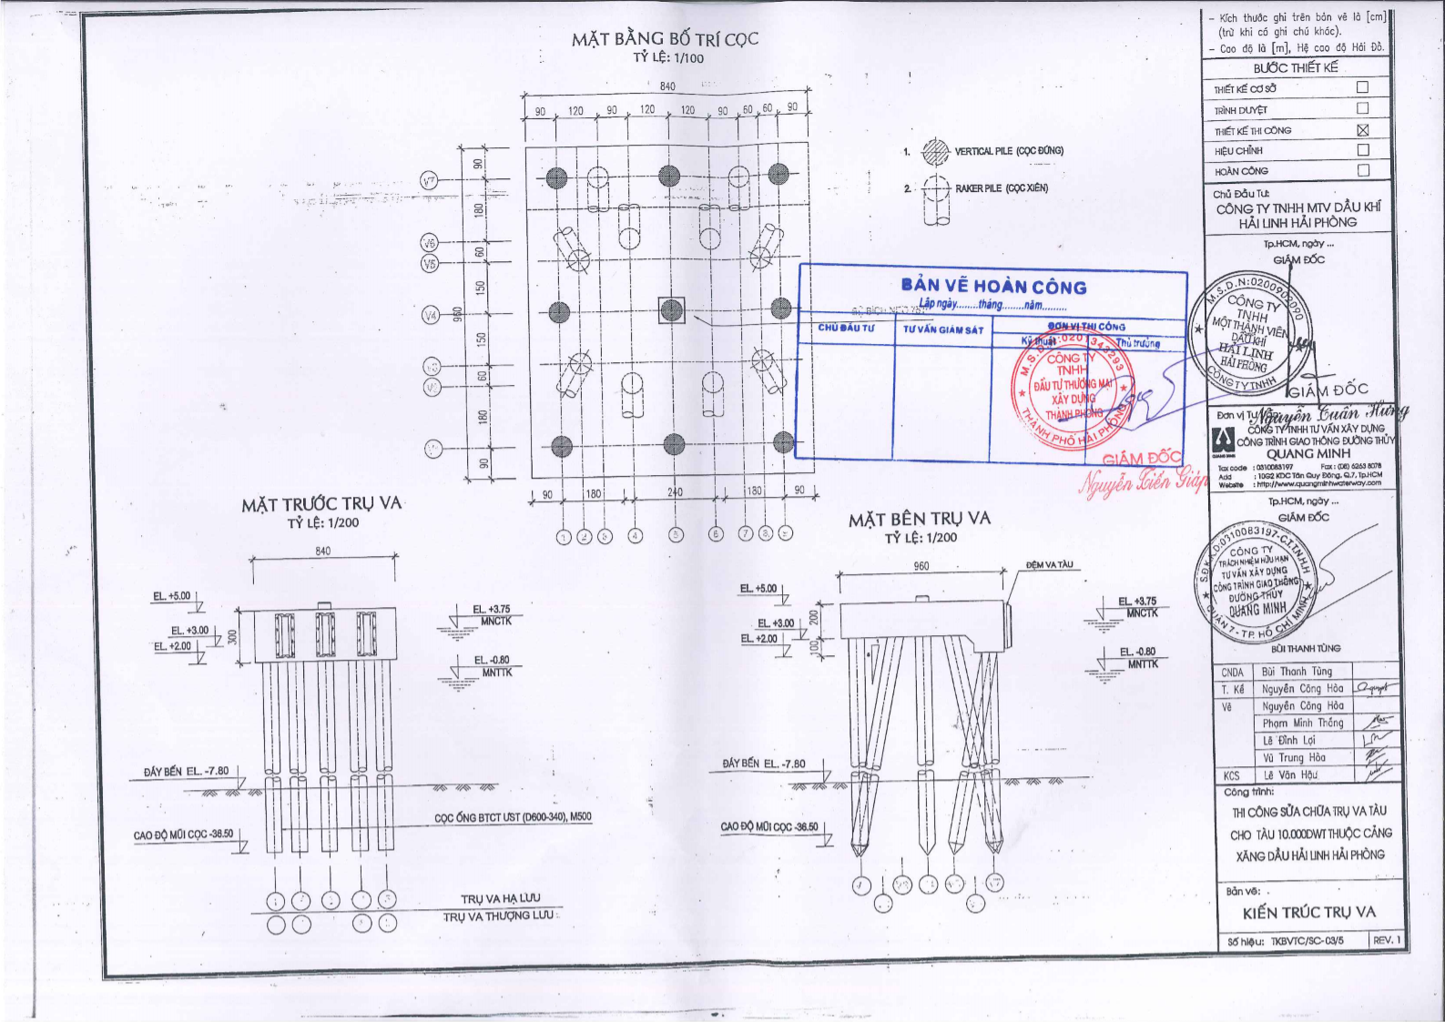
Fig. R1 (continued)
- Soil-Structure Interaction. Modeling approach (p-y curves, group effects) not described. Please clarify SAP2000 implementation.
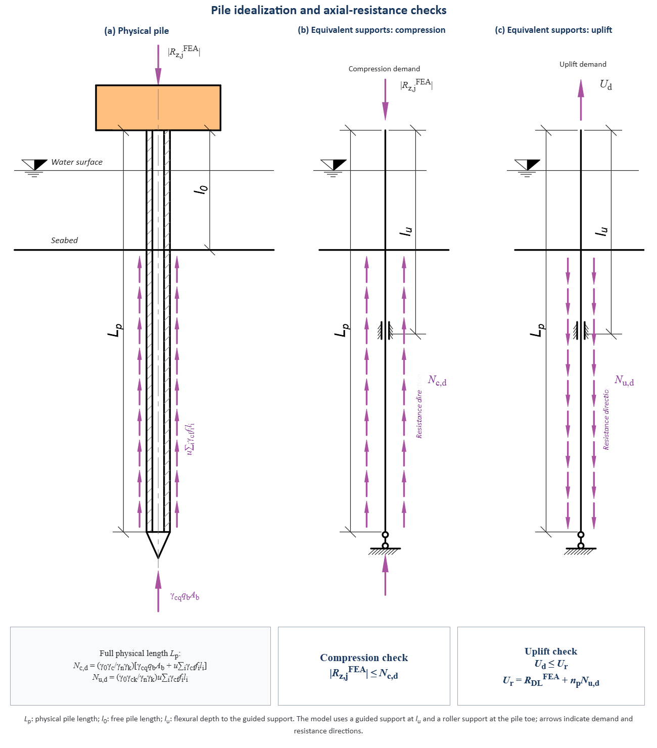
        - Pile idealization adopted in the analysis: (a) physical pile used for axial geotechnical verification, (b) equivalent guided-and-roller supports under compression, and (c) equivalent guided-and-roller supports under uplift.
Thank you. The SAP2000 implementation uses equivalent boundary conditions rather than distributed soil springs, nonlinear p-y curves, or explicit pile-group reduction factors. Compression and uplift resistances are calculated over the full embedded pile length in accordance with TCVN 10304:2014 and checked against the SAP2000 pile reactions. In SAP2000, soil effects are replaced by a guided support located within the soil at the calculated flexural depth $l_{u}=2/α_{e}$, together with a roller support at the pile toe. To preserve readability in an already information-dense manuscript, Sections 4.3 and 4.4 provide a concise but complete account of this approach, and Section 5 states its limitation. We respectfully retain the more detailed technical clarification in this response, supported by Figures R2 and R3.
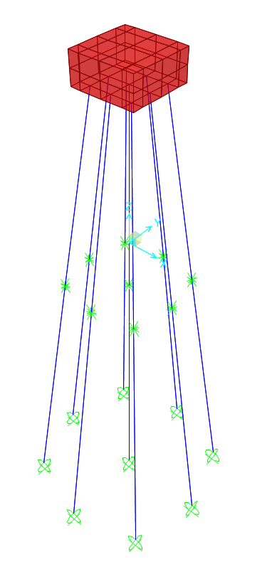
        - Representative SAP2000 model of the mooring dolphin used in the coupled analysis.
- Load Combinations. Table 6: EV-COMB not clearly defined; load factors missing. Provide complete definitions.
Table 6 now reports the SAP2000 scale factor for every load case in each linear combination: 1.0 means that the load is included at its established design value, whereas a dash denotes exclusion. EV-COMB, designated BAO in the model files, is an envelope rather than an additional linear combination; SAP2000 evaluates each constituent combination separately and retains the governing maximum and minimum responses. Table 8 gives the corresponding design actions entered into the models: the berthing-load components are 222.42, 444.83, and 0 kN; the mooring-load components are 99.05, 118.07, and 71.20 kN; the MJP live load is 9.81 kN/m2; and dead load is generated from self-weight. The applicable amplification and safety provisions are incorporated when these actions are established under PIANC, OCDI, and the relevant Vietnamese standards, so they are not applied again in Table 6. These definitions are provided in Sections 4.1 and 4.3.
In the manuscript, the explanatory paragraph immediately below Table 6 in Section 4.1 and the explanatory paragraph immediately before Table 8 in Section 4.3 are highlighted in yellow. They define the SAP2000 combination coefficients, the EV-COMB envelope operation, the numerical load inputs, and the fact that action-specific amplification and safety provisions are not applied again as combination factors.
- Benchmark Table Readability. Tables 2-4 are extremely dense. Roman numerals (I-V) confusing. Simplify with descriptive labels and consider splitting tables.
The original dense benchmark tables were removed from the main text. Detailed problem-level results are now separated by suite in Appendix Tables A2-A4, while Section 3 retains Table 3 for the computational settings and computation-time statistics and Table 4 for the cross-suite rank and Wilcoxon-Holm summary. The former Roman-numeral labels I-V have been eliminated. Full algorithm names are used in the text and summary tables; the Appendix tables use the compact labels A1-A5 only to control table width, with the complete fixed mapping stated directly below each table. The detailed tables were also reformatted using five-decimal values or scientific notation for very small numbers, restrained horizontal rules, and explicit statistical notes.
The captions of Appendix Tables A2-A4 are highlighted in yellow to identify the reformatted detailed benchmark tables. The main-text summary is retained in Tables 3 and 4, while the detailed problem-level values are provided in Appendix A.
- Statistical Keys. "SKs" column in benchmark tables not defined. Clarify abbreviations.
To avoid introducing another abbreviation, “SKs” has been removed and the column is now titled “Statistical keys.” This column contains the Best, Mean, Std, Rank, and Wilcoxon-Holm rows. Their calculation and the symbols +, -, =, and Ref. are defined in Section 3.1 and repeated below Appendix Tables A2-A4.
We again thank the Editor, the Editorial Panel, and the Reviewers for their constructive assessment. We believe that the revisions have substantially improved the clarity, reproducibility, and engineering relevance of the manuscript.
Sincerely,
Dr. Cuong Le
Corresponding author, on behalf of the authors
Thank you for being so supportive!

